**DiveMonkey Check Key RE Challenge**

Firstly, we need to see how the check key application works by default, understand the initial menu (if present) and the way the user interacts (if at all). Running the application in a window, we are presented with the following screen;

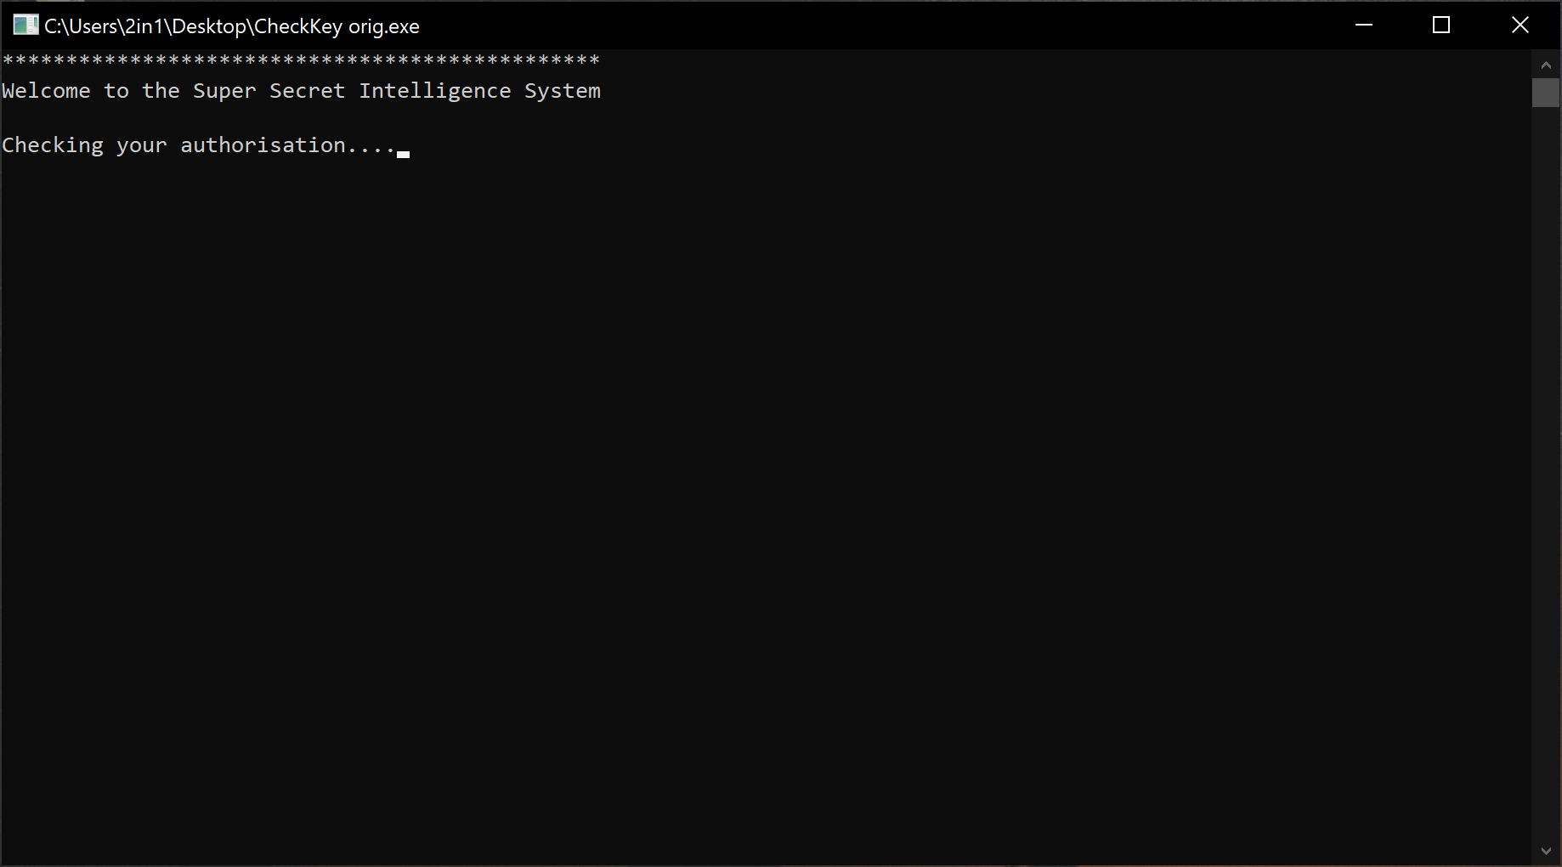

We can assume that the program is running some form of ‘check’ in the background, and the … is set to act as a counter. Upon reaching 4 full stops, the application closes itself. Interesting!

With this, we need to see if there is a subsequent message that is displayed just before it closes, should we have missed something. Running cmd, opening the program, and letting it ‘close’ we are presented with the following message;

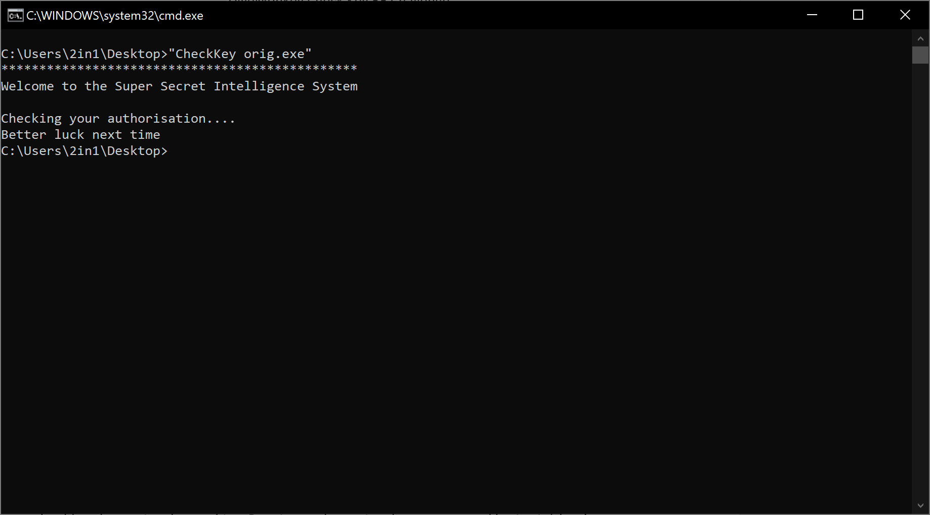

Better luck next time? Clearly we aren’t authorised by the Super Secret Intelligence System, and so, we need to delve into the code to discover the way it works, and how we can patch the application to work in a different way than it way originally designed.

For this write up, I’ve sub divided the way in which the 3 ‘main’ debuggers can be used into reverse engineering the authorisation key to be displayed (the flag) by this program.

IDA write up pages 2-4

X32DBG write up pages 5-8

Ghidra write up pages 9-11

Words of warning;

IDA Pro is NOT cheap, but very powerful. Don’t download just any ‘cracked’ version, there are some seriously advanced anti-protection embedded which could easily hide nasties! However, you can get a legal copy of IDA Freeware with reduced features and functions.

X32/64DBG is free and continuously being updated and for beginners, it is fairly easy to understand, reassemble and play around with.

Ghidra is HIGHLY temperamental, and shouldn’t be relied on. Since it’s initial release however, it has come on leaps and bounds by thankful cooperation between contributors and the NSA.

**IDA**

Loading the application with all default settings, we are brought to a flow diagram. Thankfully, the way this has been written, doesn’t lead us to trying to divide our attention into multiple graphs, jumping between them all;

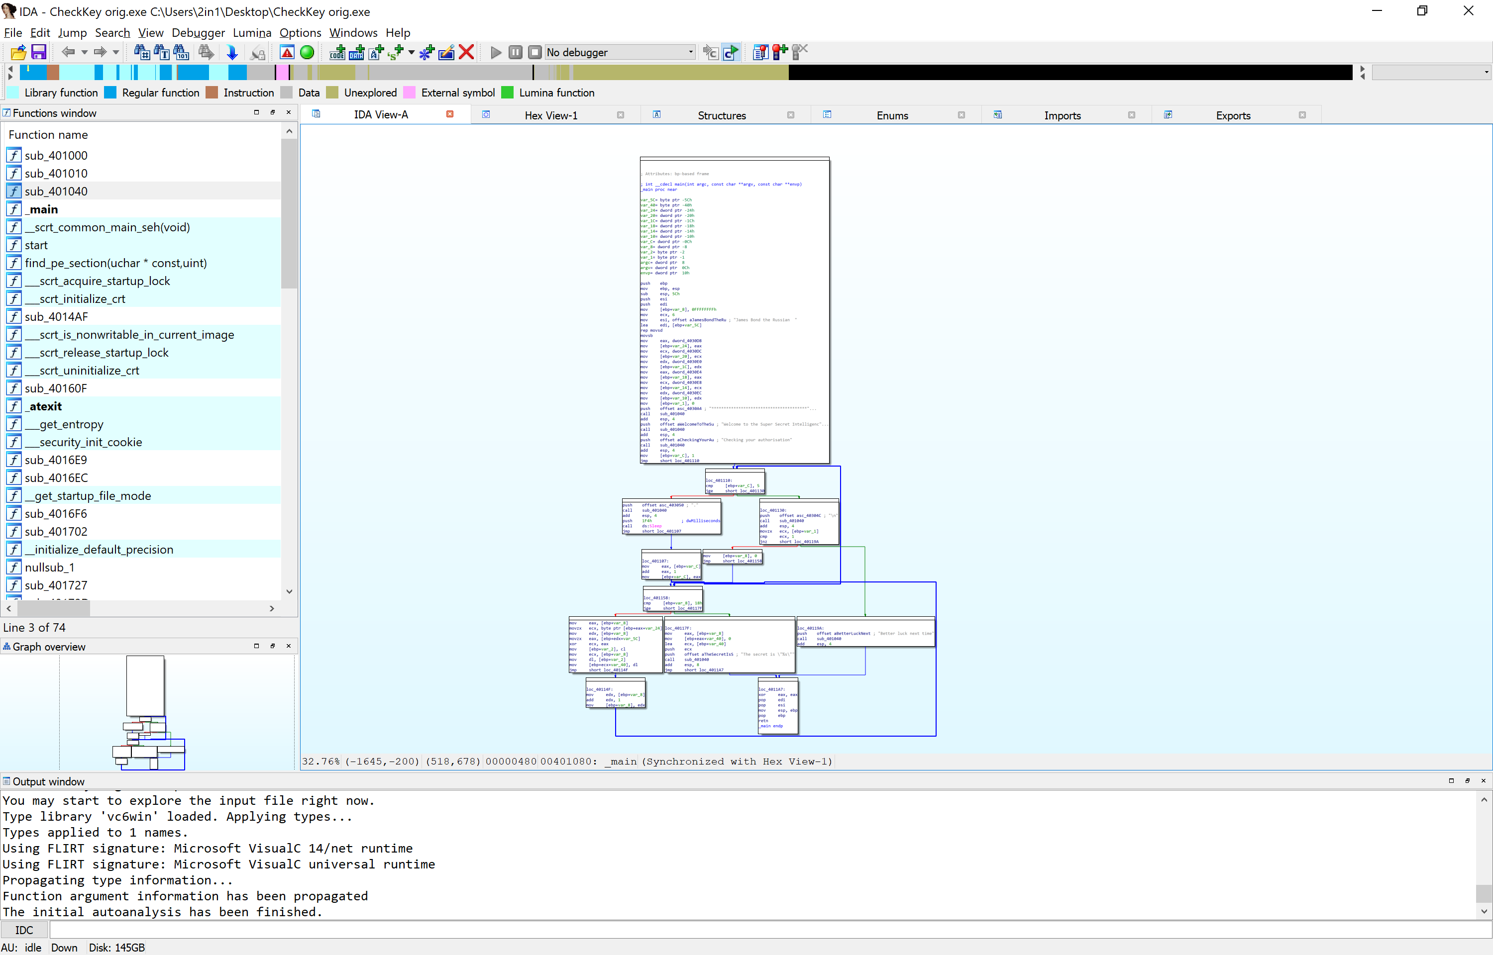

Upon closer examination of the largest box first, whilst most of it is either uninterpreted or general machine code, we can begin to see a clear display of text about a certain Russian James Bond;

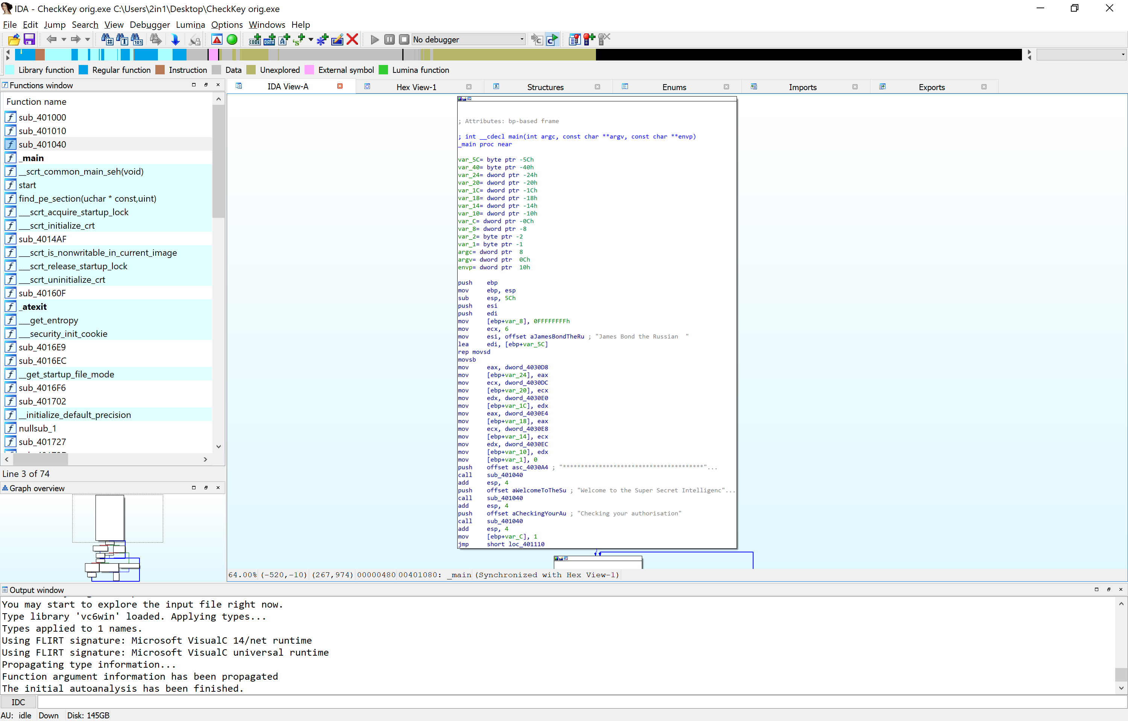Most programs will try to hide the key instead of leaving it in plain text. However, this may not always be the case..

Notice that the string is being put into the esi memory location. This is often an easy method in tracking the happenings, though in longer and more complicated programming, this is less of a good idea.

Looking at the bottom of the box, we can see that this is the initial code that was printed onto the screen when we load up the program. There is nothing else for us to look over on here, and so we follow the flow chart to the next boxes.

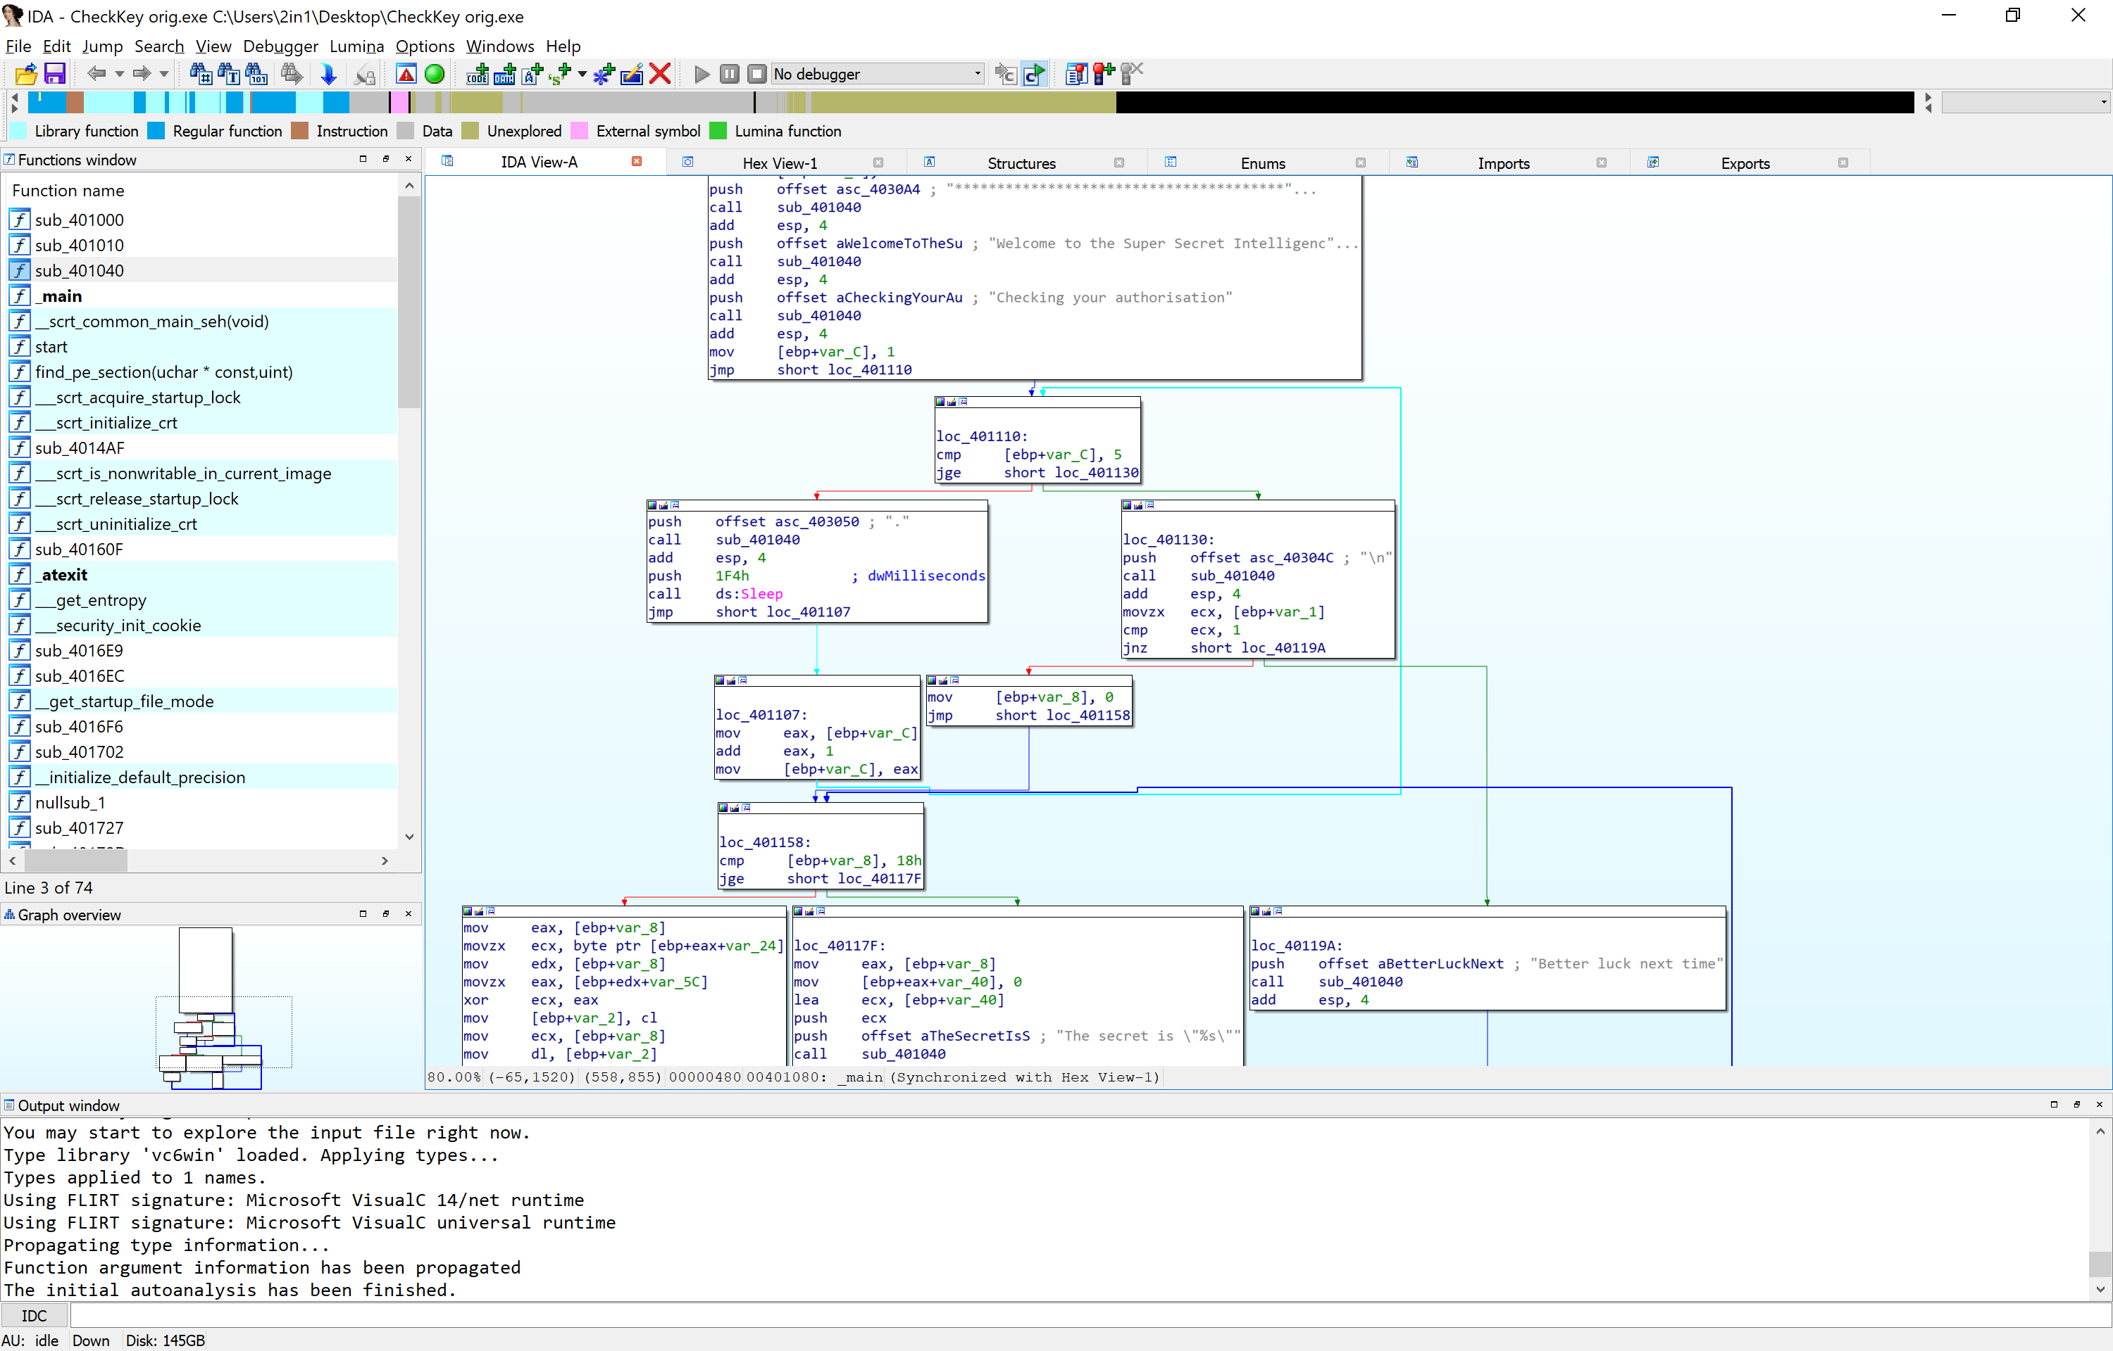Loc_401110 contains a simple compare trigger. On the 5th iteration of the loop (highlighted in bright blue) of printing 1 full stop, waiting 1 second, adding 1 into the counter, it breaks this loop and goes into another trigger and checks that the previous loop has been correctly ran.

If the loop hasn’t been correctly ran, Loc_401130 has code that will ‘Jump Not Zero’, or rather in this case, jump to the location Loc_40119A because the program failed its loop, and is a safety trigger to prevent someone gaining unauthorised access to the programs next stage.



To beat this, we need to do one of two things. Either change the compare test to ensure we get the Jump Not Zero to read as 0, or the easier method, patch to a Jump Zero. By changing the assembly, we are changing the way the program is ran to what we want it to do, opposed to its intentions.

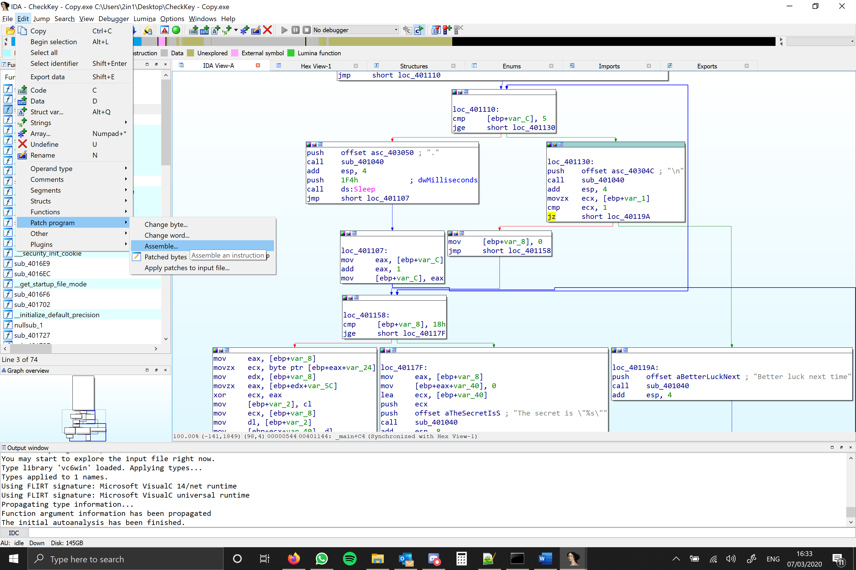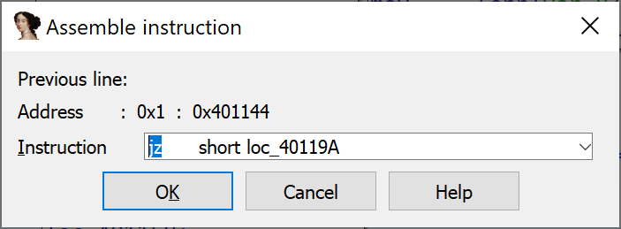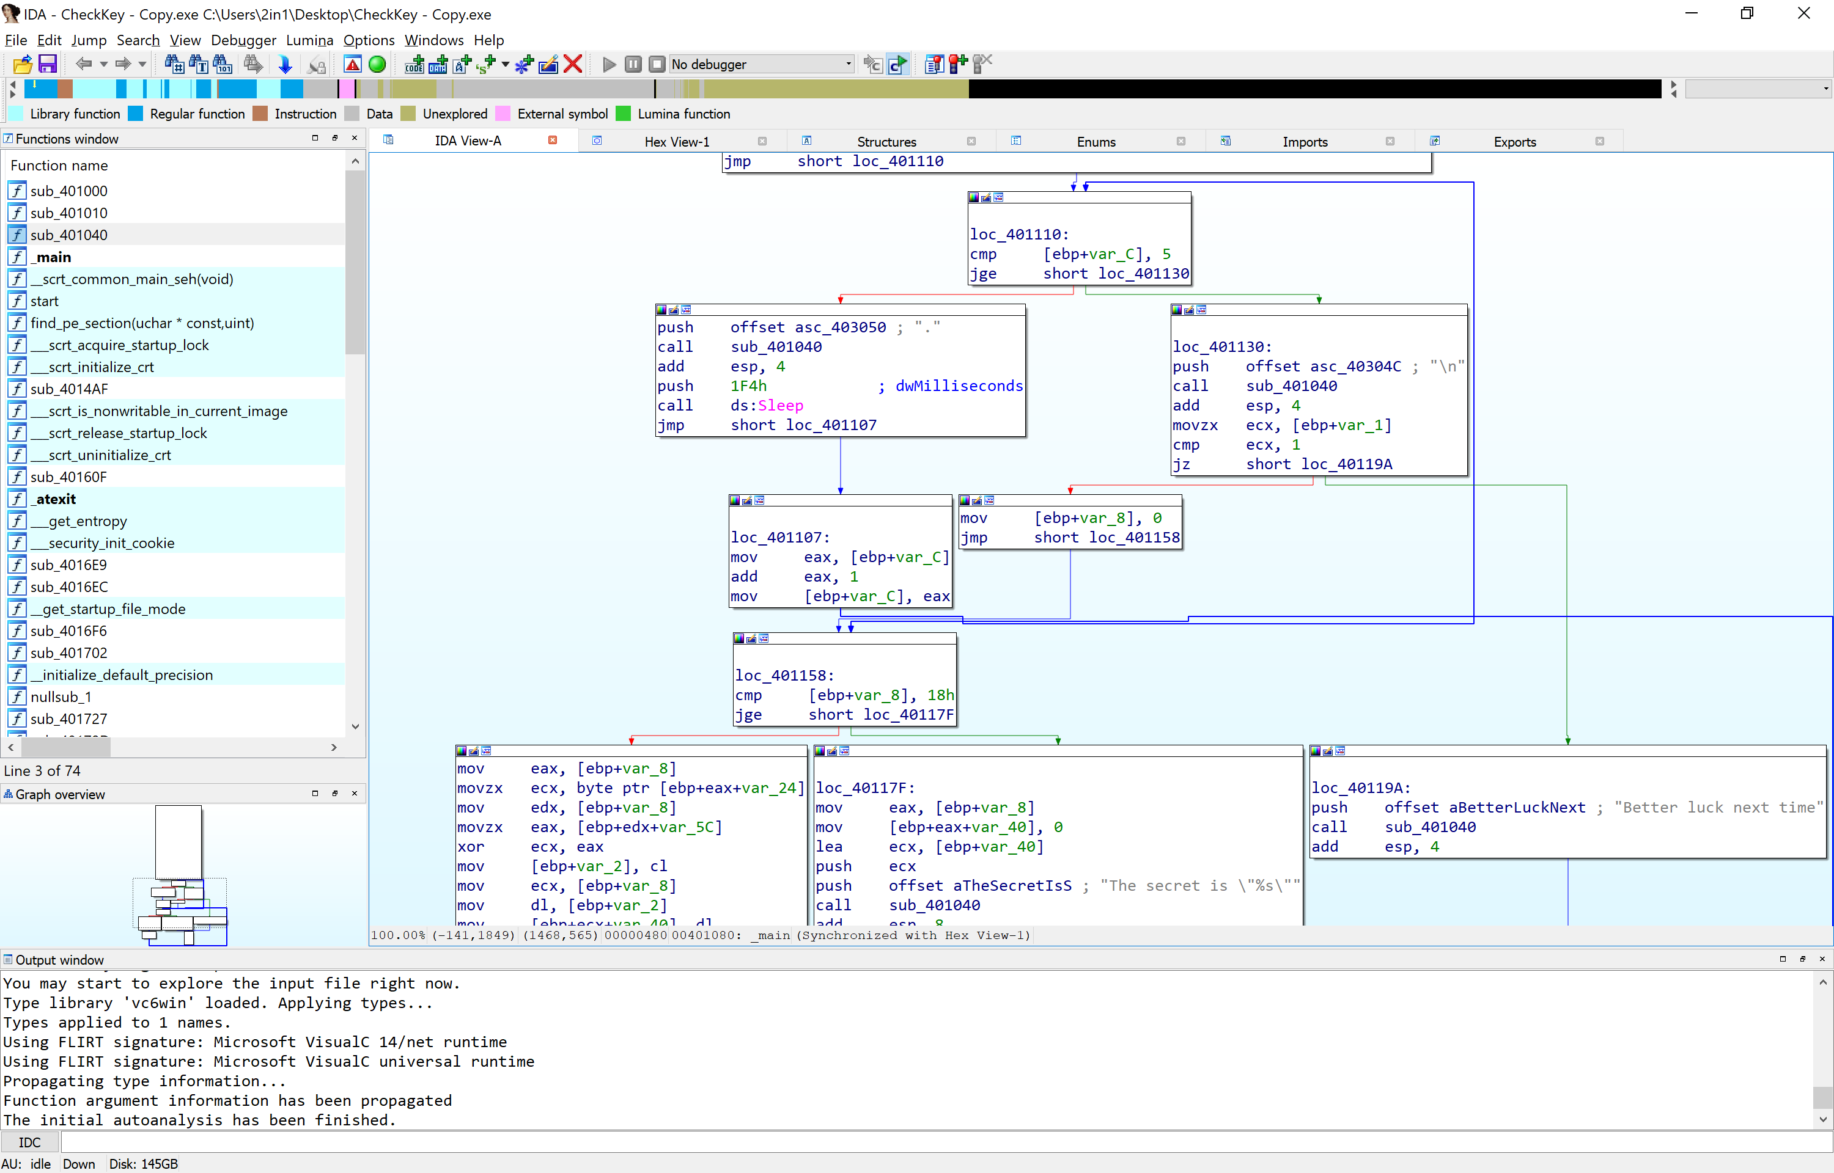

From here, we’ve now changed the way that the program runs so that instead of telling us we aren’t authorised, that we are actually, allowed to access the rest of the program. What we do now, is see how the program reacts to this simple change, as we have changed the trigger to reverse. If we weren’t granted access before, are we able to now?

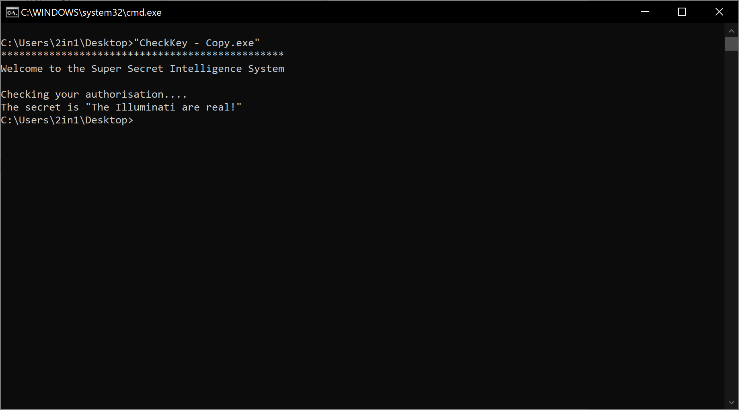



Wait, I thought James Bond was a Russian? Well, this is exactly why you should never rely on plain text information that isn’t seen by the user by default. If we had tried to trace Mr Bond in a larger program, we’d still be trying to find his whereabouts. I’ve blanked out the key, but have told you what the secret isn’t as a hint. If you get anything other than the real deal, then you’ve tried something different and it has loaded the wrong address, or you’ve jumped ahead and missed the single command swap.

If you’re more of a hex code deviant, then 75 is the hex code for assembly JNZ, to which it needs to be 74, which is JZ.

**X32DBG/X64DGB**

For starters, the program has been written to run in a 32 bit windows environment. Attempting to disassemble with x64 will inform you that you are unable to reverse a 32 bit program in a 64 bit debugger. Something simple, but could affect the way the program is run should you manage to, or the debugger actually attempt to debug in the wrong architecture.

Upon loading the application, we need to click the run button once, which will bring us to the ‘Entry Point’ of the application. This is, by definition, the (proposed!) beginning of the application code. The reason we call this the proposed Entry Point, is because some programmers will attempt to deobfuscate the way to program is run, in an attempt to prevent unauthorised modification to the program itself. Since this is a simple challenge, we can safely assume this is not the case in this instance.

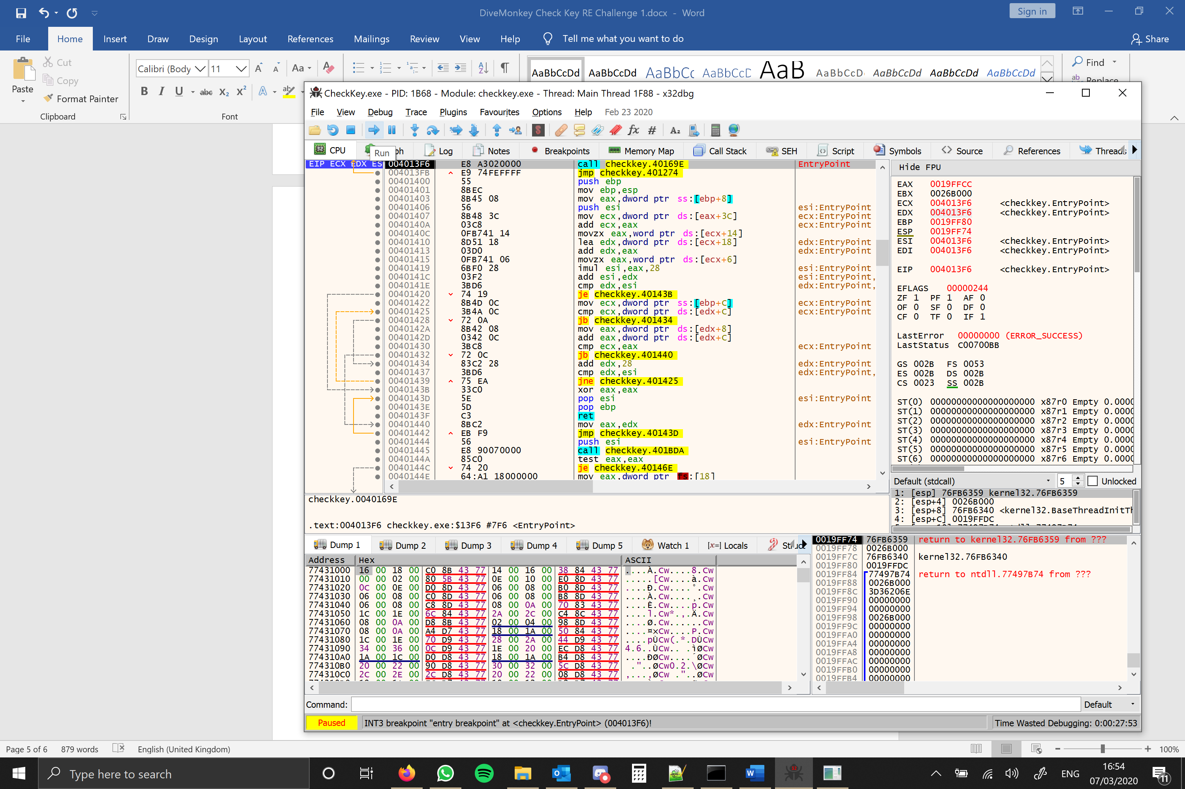

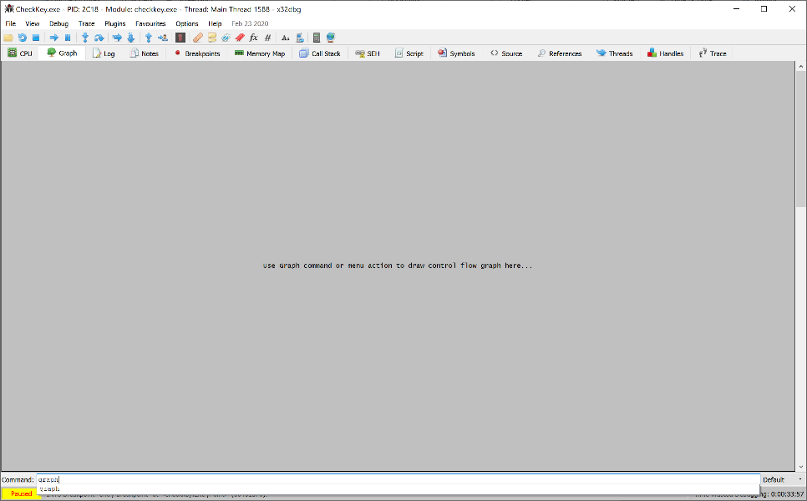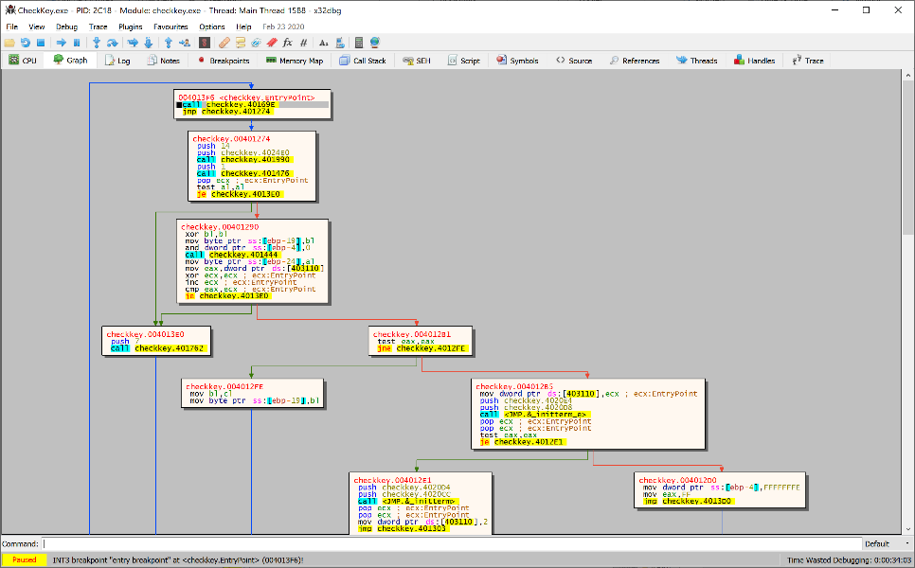Personally I find it best if we can see the way to program flows, breaking it down into a more easier bite sized chunk of code, than loads of lines that will jump between program code and windows .dll functions that we can’t change. By clicking on the graph, and typing graph in the command box, we can see the flow in which the program follows.

Should you type the common graph before getting to the entry point, we are then met with seeing the graph of the initial .dll load, to which you will need to click run once, then retype the command graph to reload the correct graph shown above.

If we follow the main graph down, we need to look for coding that exits the program and work back from there. In this case, we see a simple check to go either on with the program or quit. This is a good place to start to interrogate, see what the application displays and what we need to look into more, before the application quits.

Setting a breakpoint (default F2 or right click > breakpoint > toggle) is a debuggers dream to stop a program from doing anything, effectively ‘pausing’ it.

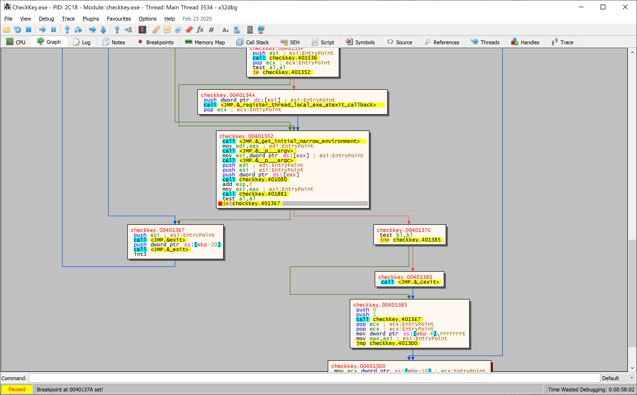

By setting a breakpoint here, we are pausing the program just before the check completes and goes into further code, or closing down. Upon looking at the application screen itself however, we are face with something peculiar however, stating that we are on the right track, but in the wrong graph ‘tree’;

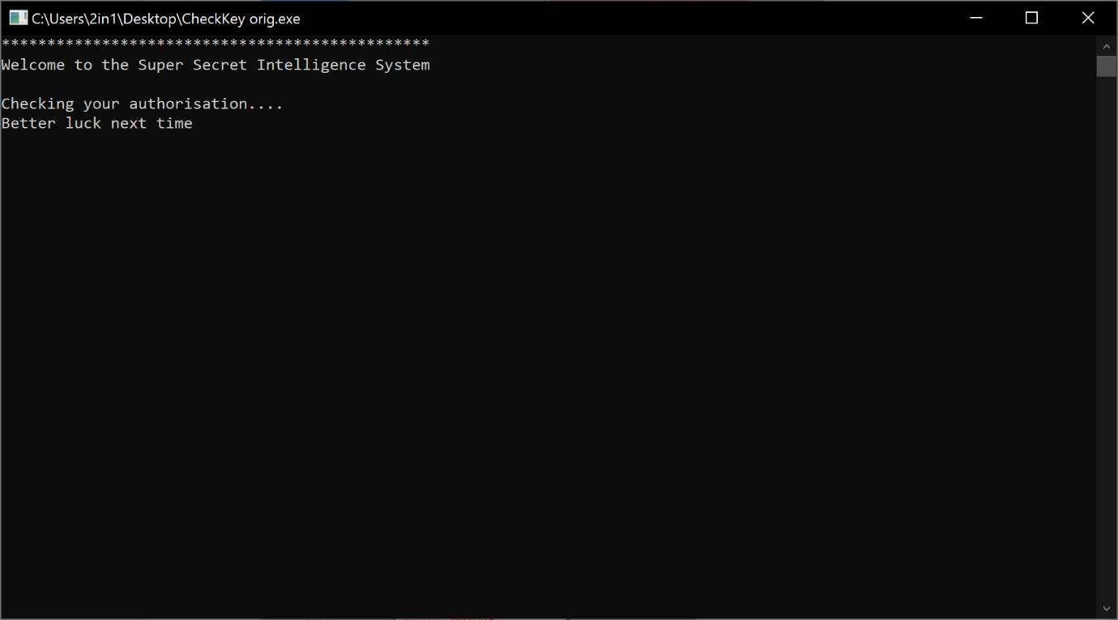With this message, we can safely assume that our breakpoint has caught the tail end of any checks and the loop failed because we aren’t authorised. Time to look at this box more thoroughly and the calls to other code.

Looking at checkkey.401881, we see nothing that we can use, for it’s a continued set of checks, tests and jumps;

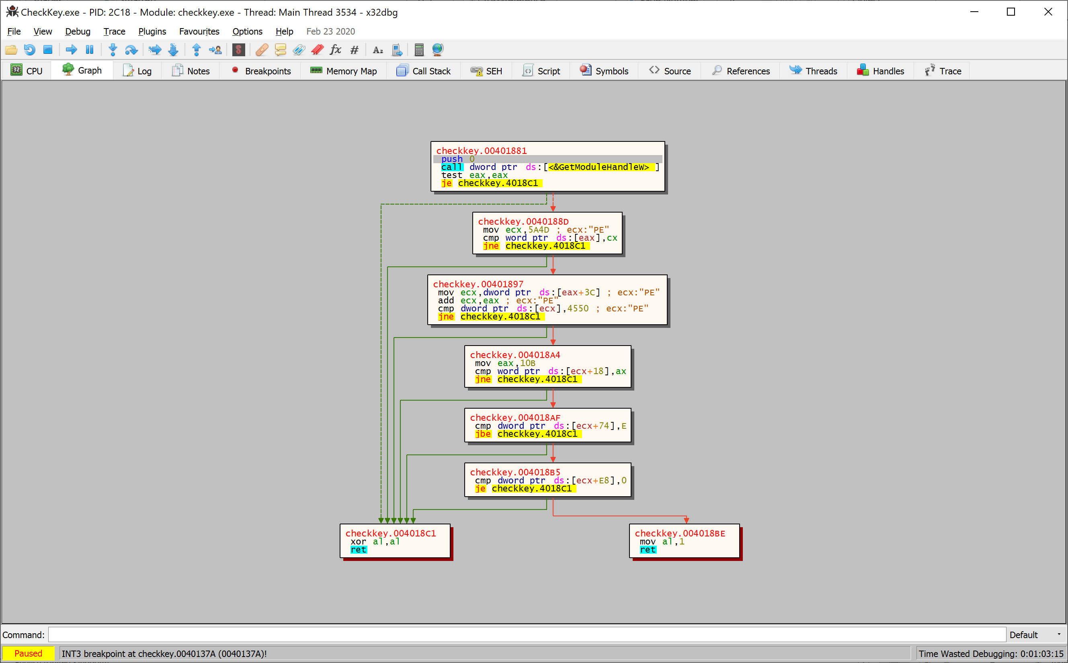

However, if we then look into checkkey.401080 (found by resetting the graph or program to entrypoint) then we see a familiar set of strings;

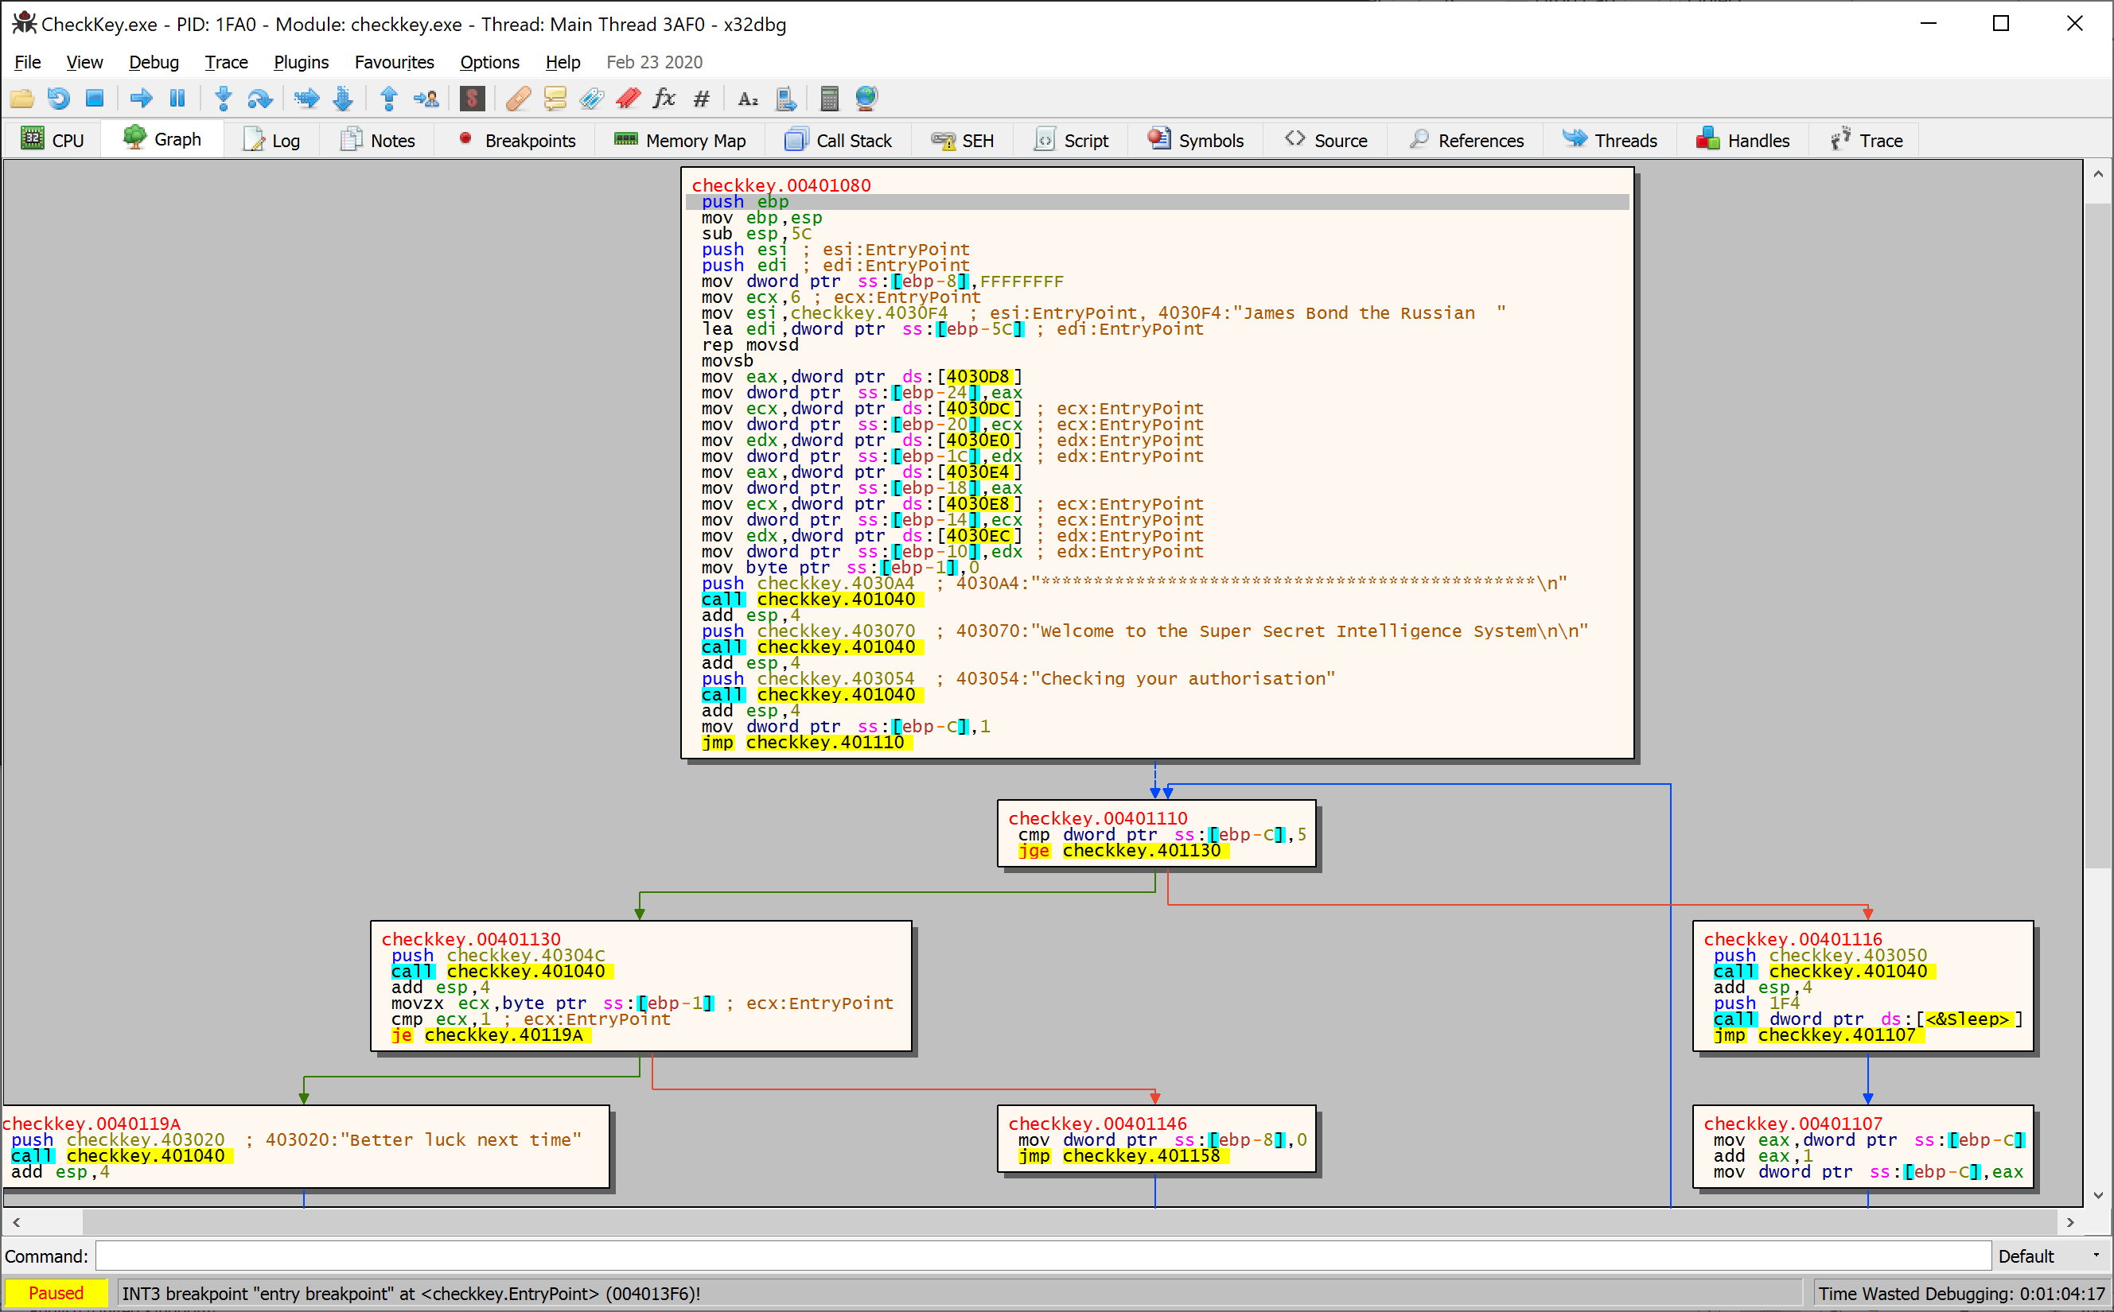Upon closer examination of the box, we can see a clear display of text about a certain Russian James Bond. Most programs will try to hide the key instead of leaving it in plain text. However, this may not always be the case..

But we don’t see the key displayed before the line of stars and the welcome screen… Whilst it is safe to assume this is not the key, Mr Bond gets moved into the esi memory location, in which it could be called upon later. We need to get the program to display this data to ensure that Mr Bond is our flag however..

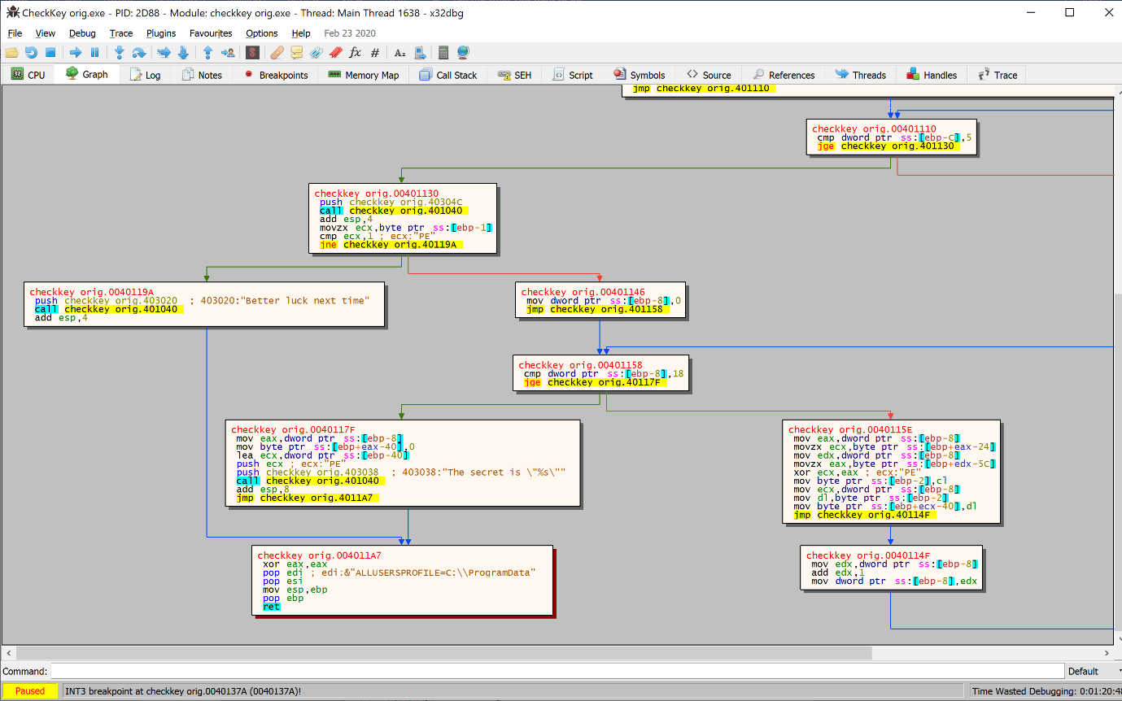Looking at the graph, we can see a specific point in which the program goes 1 of 2 ways. Telling us to have better luck, or displays the secret key. We need to change the JNE – Jump If Not Equal into a JE – Jump If Equal to reverse the way in which the program operates. By setting a breakpoint here, will help if you need to restart the program and return.

Right clicking on ‘jne checkkey.40119A’ and follow in disassembler will lead you to this bunch of code;

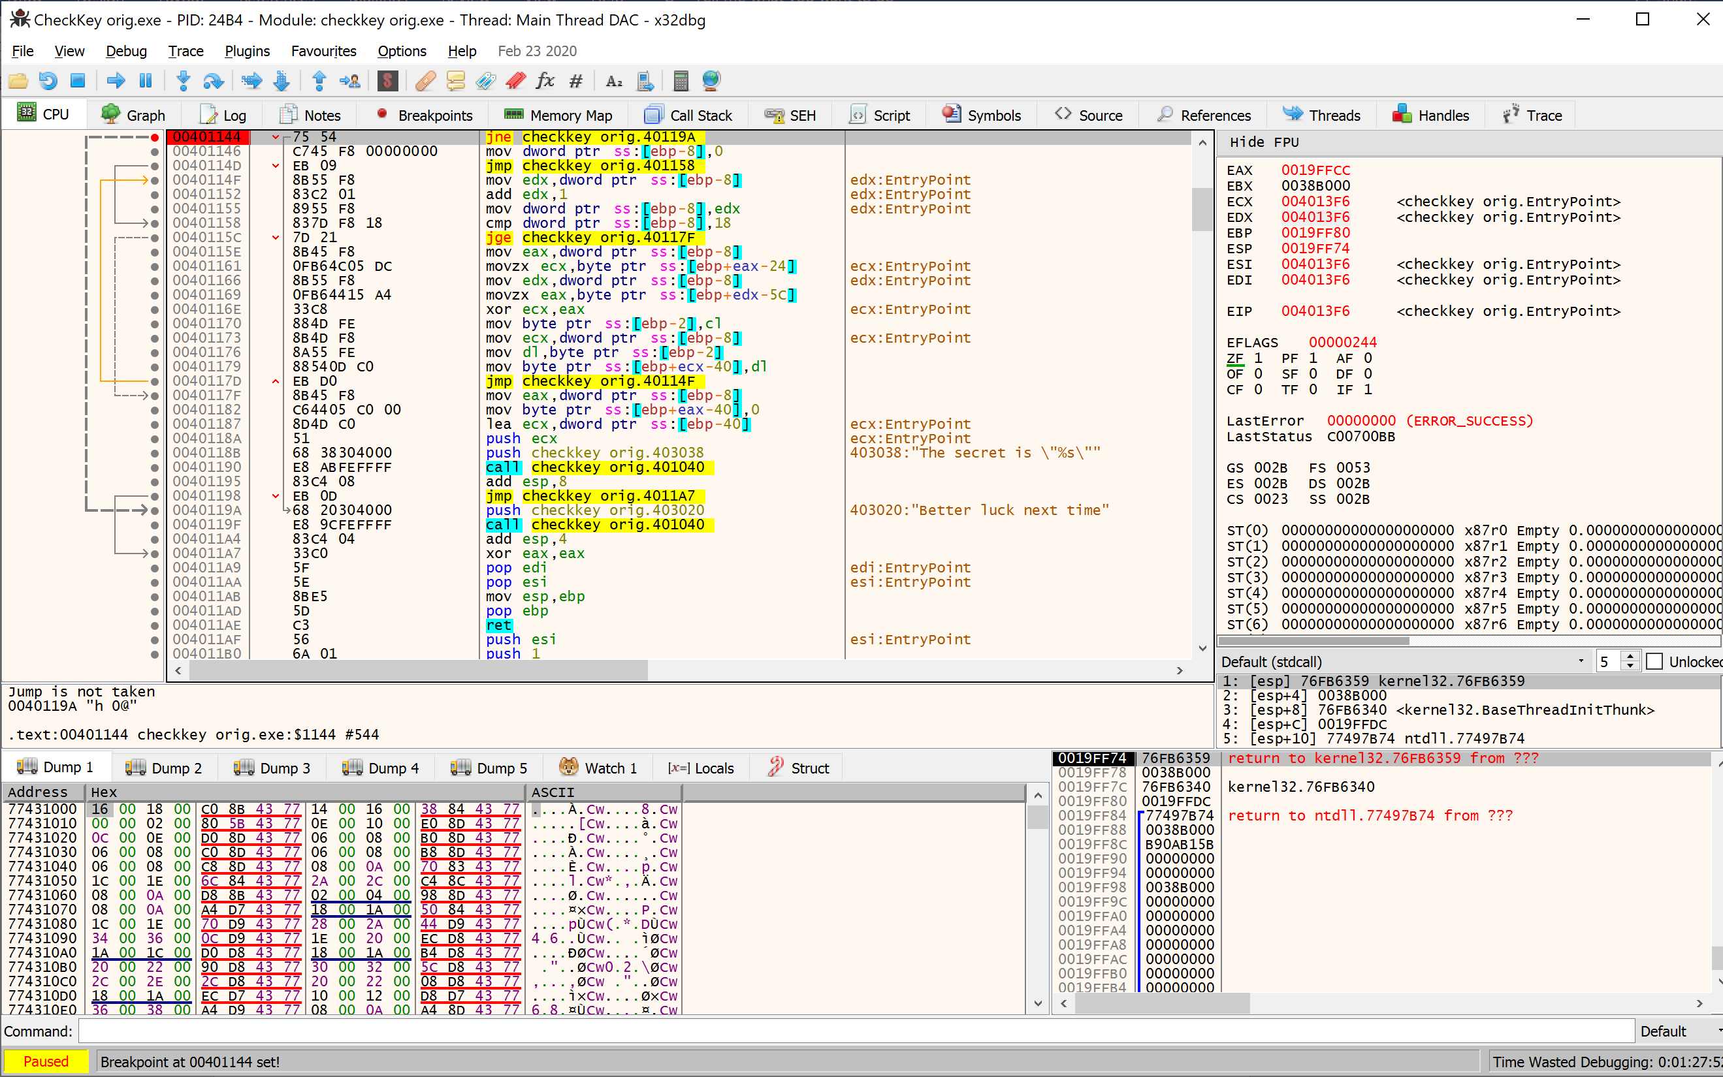

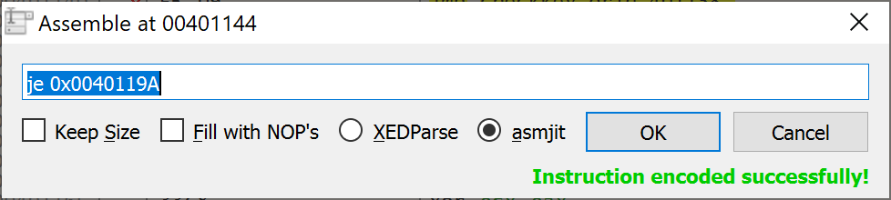From here, right click and find assemble to load the screen to edit the assembly code directly. Change it to reflect JE opposed to JNE as follows;

From here, we are now just patching the file by clicking on the plaster/band aid symbol and patching the file. Ensure you named it something else to avoid writing errors!;

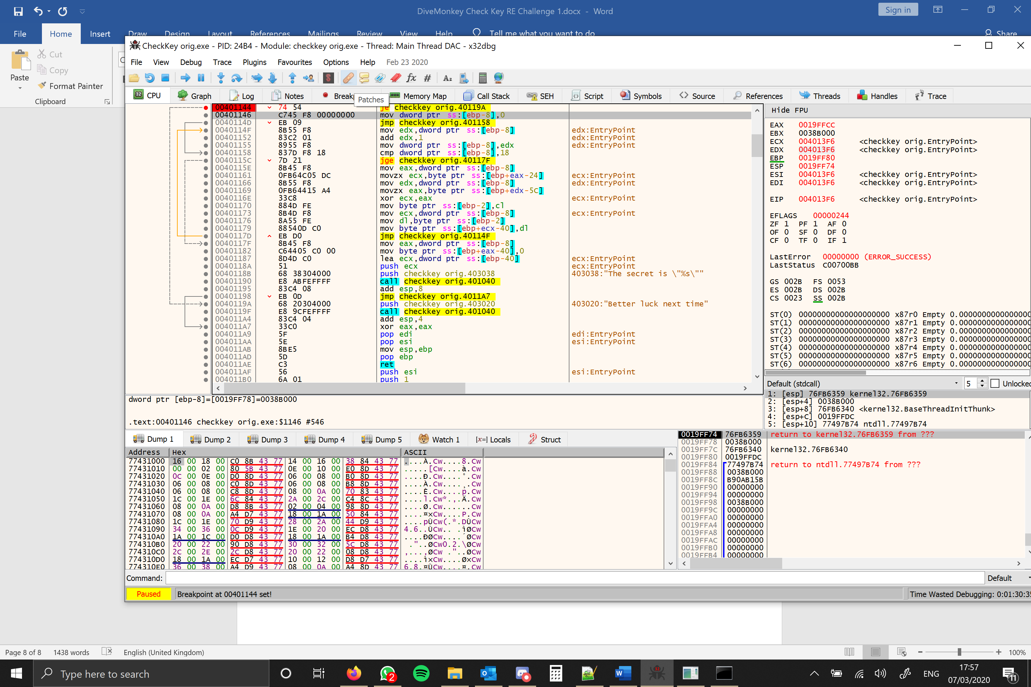

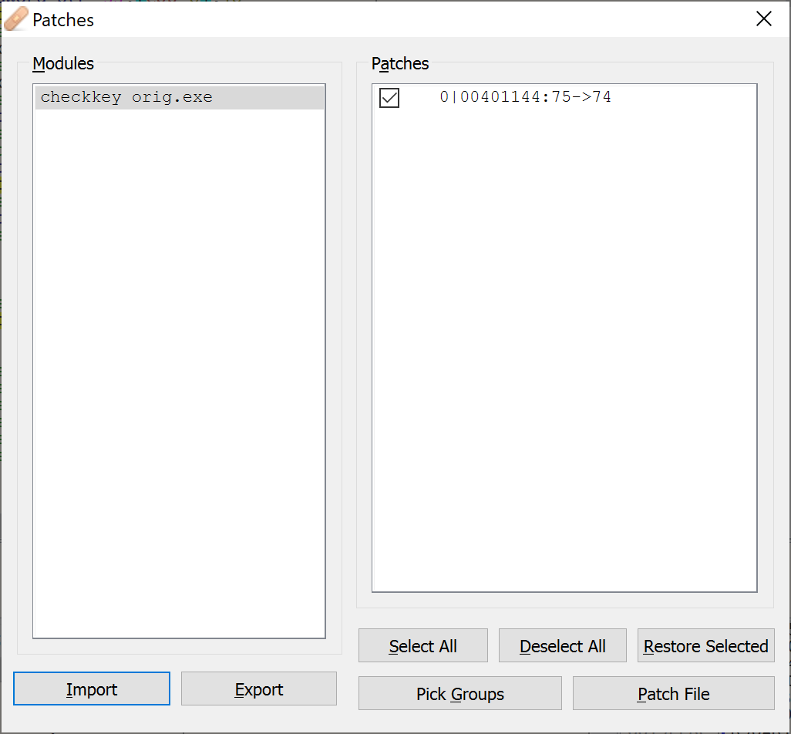





Wait, I thought James Bond was a Russian? Well, this is exactly why you should never rely on plain text information that isn’t seen by the user by default. If we had tried to trace Mr Bond in a larger program, we’d still be trying to find his whereabouts. I’ve blanked out the key, but have told you what the secret isn’t as a hint. If you get anything other than the real deal, then you’ve tried something different and it has loaded the wrong address, or you’ve jumped ahead and missed the single command swap.

**Ghidra**

Using Ghidra we need to firstly import the file into a project, then subsequently analyse the program. Use the default options, allow Ghidra to analyse what it can then ignore the subsequent error, it’s not pertinent. The most interesting part of Ghidra is the ability to see assembly, hex and the language the application has been written in, albeit rather mangled.

Firstly, we need to go to the tree that holds the text of the application, called .text.

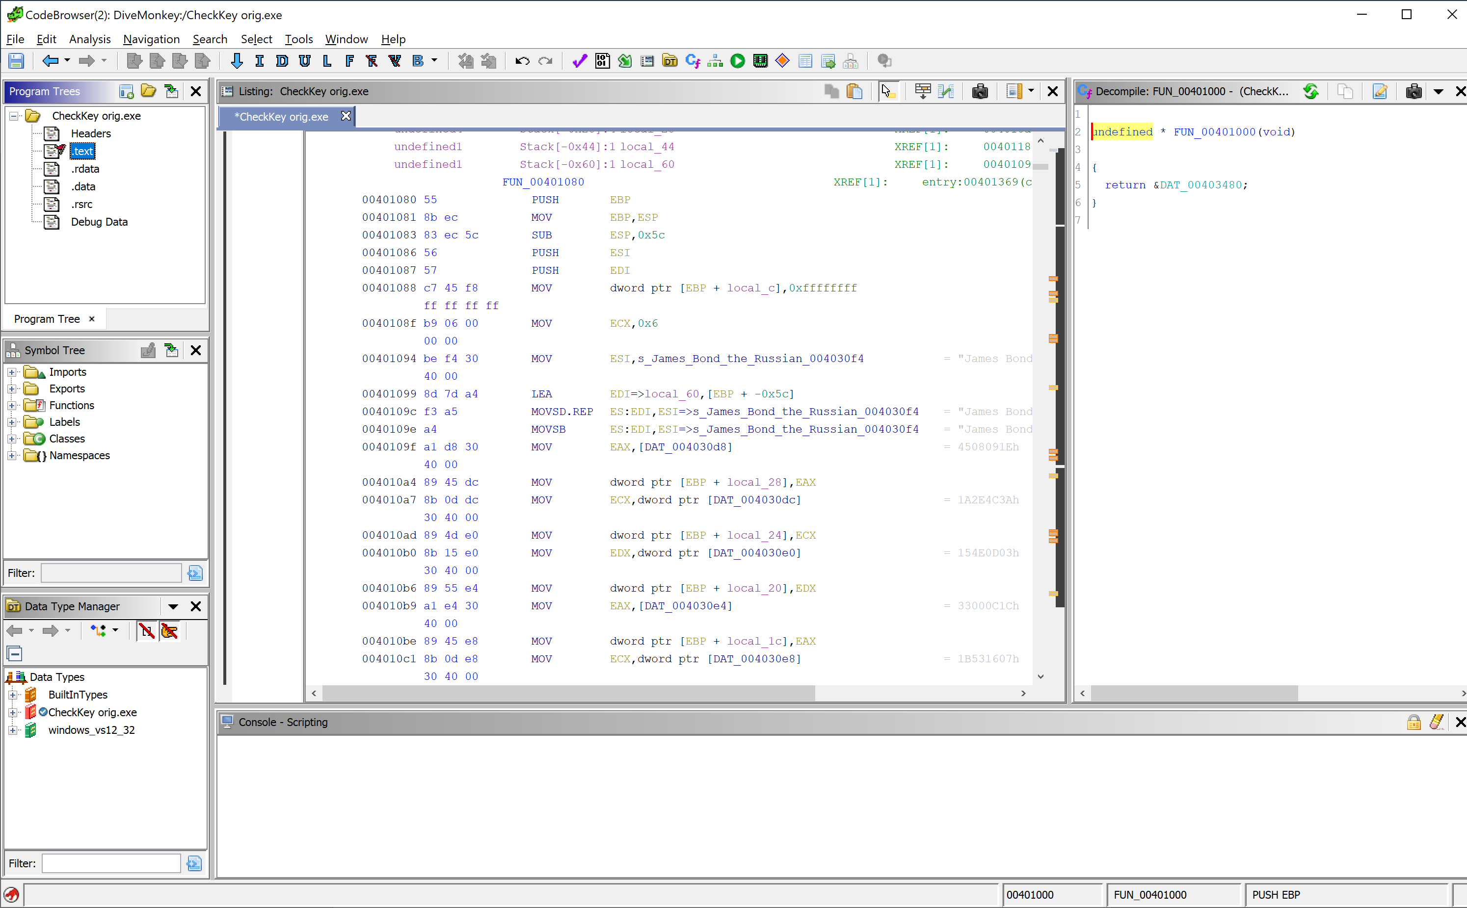

From this, we scroll down until we can find some strings that we have seen in the program earlier. After a few lines, we find out that we have a James Bond string tucked away in the program, which is as good of a place as any given we haven’t seen this string by default. Upon double clicking, we can see on the right side of the gui that Ghidra has attempted to reconstruct assembly code into a programming language (C/C++ in this case)

If we scroll down on this, we begin to see strings that we have seen in the program when it’s run normally.

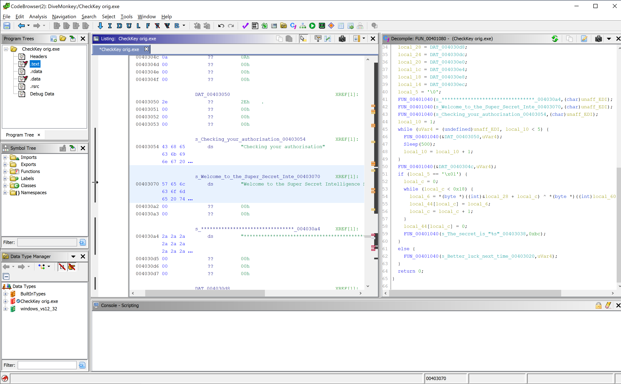

Scrolling down further, we also see a snippet of strings that we haven’t yet seen, which is where we will begin our investigation/reversal;

Looking at this pseudo code, we can see an outline of an if check and an embedded loop. Double clicking on the word if, will lead the debugger into the particular line of code in which that trigger functions. What we need to do is reverse the if-then-else. By default, this if goes to else and boots us, however, by reversing the jump condition.

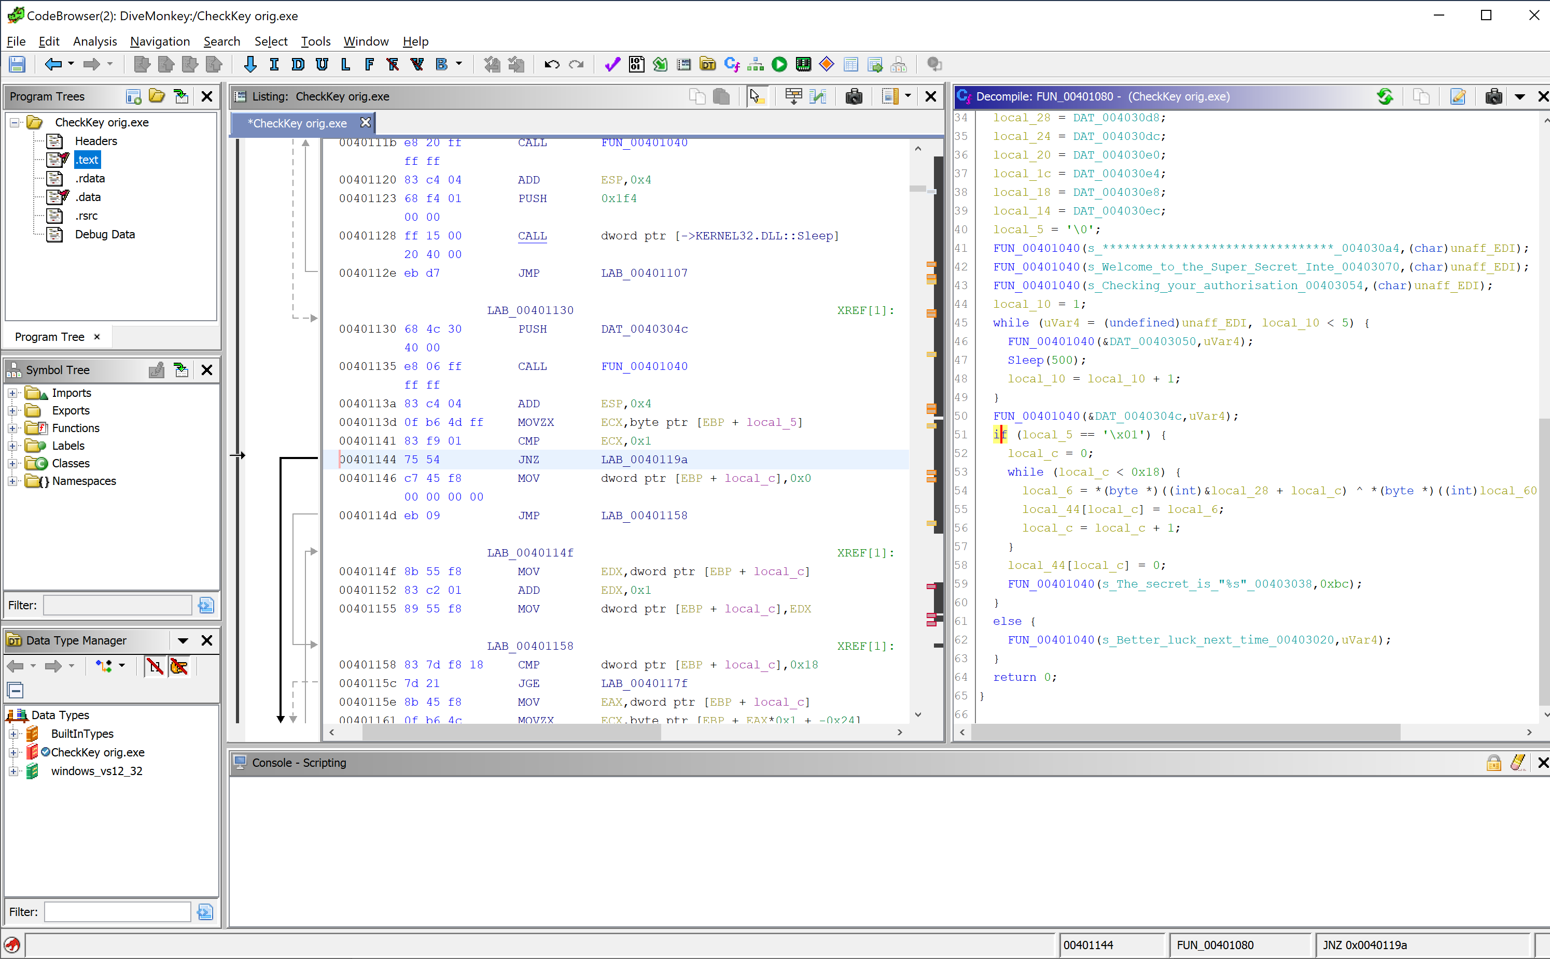 Currently the code is set to Jump If Not Zero, i.e a flag has been triggered and therefore do not go to this code location. We need to patch this instruction, but right clicking on this line, and clicking Patch Instruction (or Control + Shift + G by default) and change this function to JZ instead.

From here, we need to test what this change has done as each change will change the behaviour, and is easier to revert 1 change than track what every change may have done.

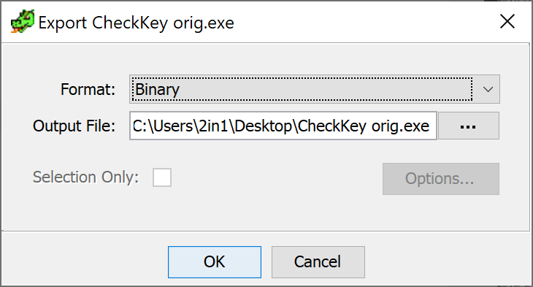Set a path for the export (I used my Desktop) but when exported, it will add .bin on the end of the file as well. Therefore, ensure that you can edit your file extensions so you can remove it.





Wait, I thought James Bond was a Russian? Well, this is exactly why you should never rely on plain text information that isn’t seen by the user by default. If we had tried to trace Mr Bond in a larger program, we’d still be trying to find his whereabouts. I’ve blanked out the key, but have told you what the secret isn’t as a hint. If you get anything other than the real deal, then you’ve tried something different and it has loaded the wrong address, or you’ve jumped ahead and missed the single command swap.